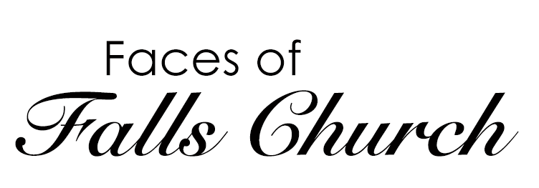

Episode 1:
First Friday of Falls Church

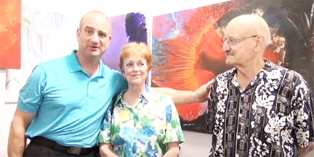
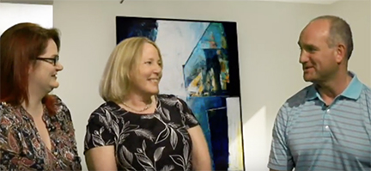

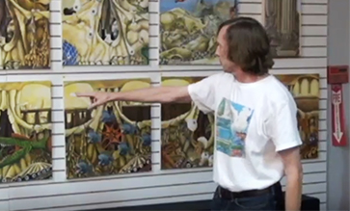
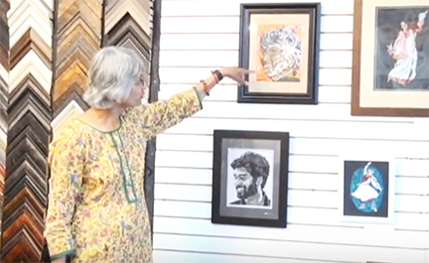
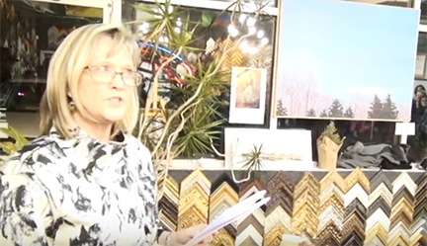

Faces of Falls Church focuses on local community voices and is produced by Melissa Robison and Amanda Lovins, members of Falls Church Cable Access Corporation (FCCAC), the public access partner at FCC-TV. Our first episode features First Friday of Falls Church.

Faces of Falls Church airs on FCC-TV on Wednesdays at 7:00 pm on these channels: RCN Channel 2, Cox Channel 11, and Verizon Channel 35. We also post episodes on our YouTube Channel, Falls Church Public Access TV. Stay tuned for future episodes!

Make Your Own TV Program! |  | Check out some other FCCAC Programs in Production
You can produce your own show. The first step to becoming a public access producer is to become a member of FCCAC.  See our membership application on the back side of this flyer. |  | We have several programs in production at FCCAC including:  - International Investor  - Creative Cauldron  - Inner Loop  - Falls Church Access  - American Diplomacy at Risk  Website:  http://www.fallschurchcableaccess.org/programming.html  YouTube:  Falls Church Public Access TV
Falls Church Cable Access Corporation
7124 Leesburg Pike, Door 20 Falls Church, VA 22043
Website: www.fallschurchcableaccess.org | YouTube: Falls Church Public Access TV

Become a Member of FCCAC!
Join online: http://www.fallschurchcableaccess.org/membership.html
or
Fill out our Membership Application below:

Membership Information |  | Member Contact Information
The first step to becoming a public access producer is to become a member of FCCAC.  Residents of the City of Falls Church, non-residents interested in producing or assisting with a public access program for broadcast on FCC-TV, or non-residents who are representatives of businesses or organizations in the City of Falls Church may be FCCAC members.  Membership Levels:  Please chose a membership level:  INDIVIDUAL  ☐ Falls Church City Residents - $25  ☐ Non-Falls Church City Residents - $40  FAMILIES  ☐ Falls Church City Residents - $35  ☐ Non-Falls Church City Residents - $60  NON-PROFIT ORGANIZATIONS  ☐ Falls Church City 501(c)(3) Organizations - $75  CORPORATIONS  ☐ Falls Church City For-Profit Companies - $100 |  | Please print (not cursive) for legibility.  Name: ______________________________  Street Address: _______________________  Address 2: ___________________________  Phone: ______________________________  Email: _______________________________  Method of Payment: ___________________  Signature: ____________________________  Please send checks to:  Falls Church Cable Access Corporation  7124 Leesburg Pike  Falls Church, Virginia 22043  Attention: Treasurer  ----------------------------------------------------------  FOR OFFICE USE ONLY  Date Received _______ Received by: __________  Date Entered: ___________  ☐ New Member ☐ Renewal

All members will receive information and news emails from FCCAC. For questions and additional membership information, please contact Melissa Robison, FCCAC Membership Chair, at melissa2510@gmail.com

