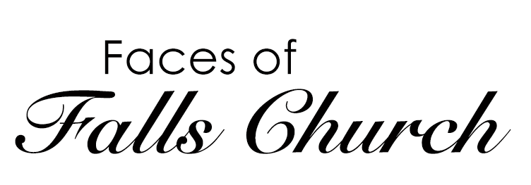

Focusing on our Community

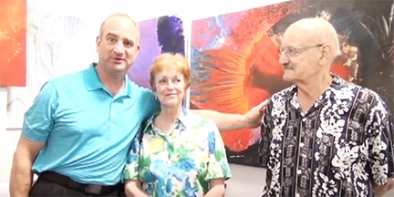
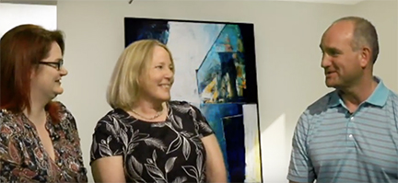

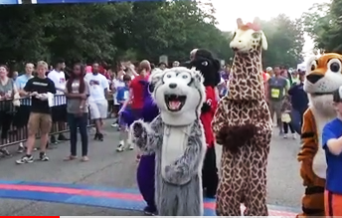
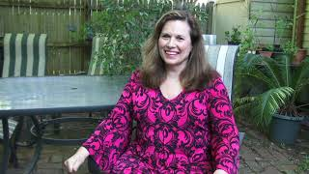
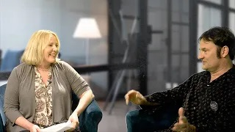

Produced by Melissa Robison and Donna Byrne, Faces of Falls Church focuses on local community voices. Our show has featured FIRSTFriday of Falls Church, Absurd Productions Pictures, Run for the Schools, Falls Church Chamber of Commerce, Watch Night, and more!

Faces of Falls Church airs on FCC-TV on Wednesdays and Thursdays at 7:30 p.m. on these channels: RCN Channel 2, Cox Channel 11, and Verizon Channel 35. We also post episodes on our YouTube Channel, Falls Church Public Access TV. Stay tuned for future episodes!

Make Your Own TV Program! |  | Check out some other FCCAC Programs in Production
You can produce your own show. The first step to becoming a public access producer is to become a member of Falls Church Cable Access Corporation.  See our membership application on the back side of this flyer. |  | We have several programs in production at FCCAC including:  - Faces of Falls Church  - International Investor  - Kush Kids  - Inner Loop  - Falls Church Access  - The Emerald Planet  Website:  http://www.fallschurchcableaccess.org/programming.html  YouTube:  Search for: Falls Church Public Access TV
Falls Church Cable Access Corporation (FCCAC)
121 Mustang Alley, Falls Church, VA 22043
Website: www.fallschurchcableaccess.org | YouTube: Falls Church Public Access TV

Become a Member of FCCAC!
Join online: http://www.fallschurchcableaccess.org/membership.html
or
Fill out our Membership Application below. Make checks payable to FCCAC.

Membership Information |  | Member Contact Information
The first step to becoming a public access producer is to become a member of FCCAC.  Residents of the City of Falls Church, non-residents interested in producing or assisting with a public access program for broadcast on FCC-TV, or non-residents who are representatives of businesses or organizations in the City of Falls Church may be FCCAC members.  Membership Levels:  Please chose a membership level:  INDIVIDUAL  ☐ Falls Church City Residents - $25  FAMILIES  ☐ Falls Church City Residents - $35  NON-PROFIT ORGANIZATIONS  ☐ Falls Church City 501(c)(3) Organizations - $75  CORPORATIONS  ☐ Falls Church City For-Profit Companies - $100 |  | Please print (not cursive) for legibility.  Name: ______________________________  Street Address: _______________________  Address 2: ___________________________  Phone: ______________________________  Email: _______________________________  Method of Payment: ___________________  Signature: ____________________________  Make Checks Payable to FCCAC and send to:  Falls Church Cable Access Corporation  121 Mustang Alley  Falls Church, Virginia 22043  Attention: Treasurer  ----------------------------------------------------------  FOR OFFICE USE ONLY  Date Received _______ Received by: __________  Date Entered: ___________  ☐ New Member ☐ Renewal

All members will receive information and news emails from FCCAC. For more information, email info@fallschurchcableaccess.org .

